Raper, Steve
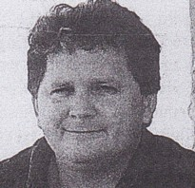
Assistant Divisional Forest Officer with CALM at Wanneroo in 1990. District Manager in Dwellingup in late 1990s-2000.

